ALU Program:-

library IEEE;
use IEEE.STD_LOGIC_1164.ALL;
use IEEE.STD_LOGIC_ARITH.ALL;
use IEEE.STD_LOGIC_UNSIGNED.ALL;
entity bit4 is
Port (
a : in STD_LOGIC_VECTOR (3 downto 0);
b : in STD_LOGIC_VECTOR (3 downto 0);
op : in STD_LOGIC_VECTOR (2 downto 0);
c : out STD_LOGIC_VECTOR (4 downto 0)
);
end bit4;
architecture Behavioral of bit4 is
begin
Process(a,b,Op)
Begin
Case op is
When "000" =>
c <= ('0' & a) + ('0' & b);
When "001" => c <= ('0' & a) - ('0' & b);
When "010" => c <= ('0' & a) AND ('0' & b);
When "011" => c <= ('0' & a) OR ('0' & b);
When "100" => c <= ('0' & a) XOR ('0' & b);
When "101" => c <= ('0' & a) NAND ('0' & b);
When "110" => c <= ('0' & a) XNOR ('0' & b);
When others => c <= '0' & (not a);
End case;
End process;
end Behavioral;

OUTPUT:-
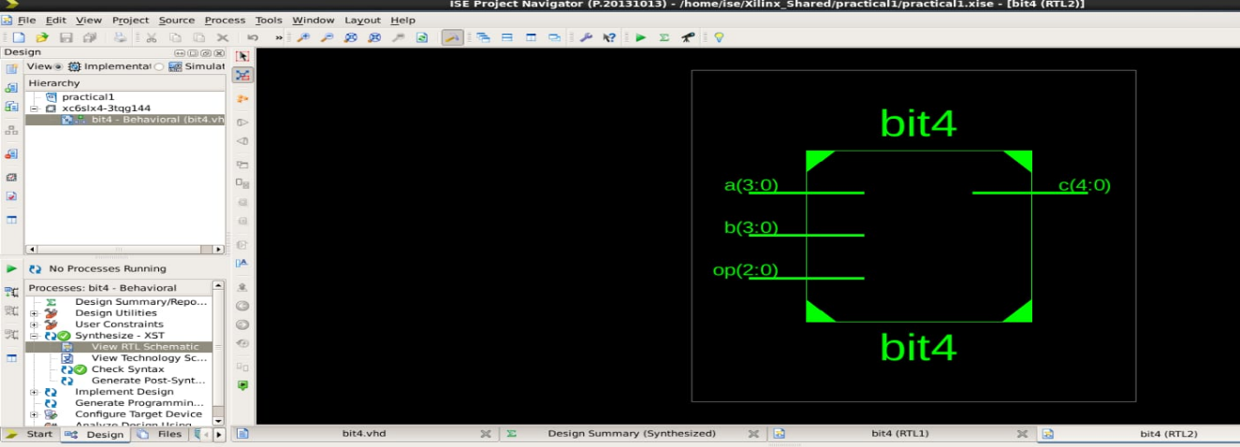

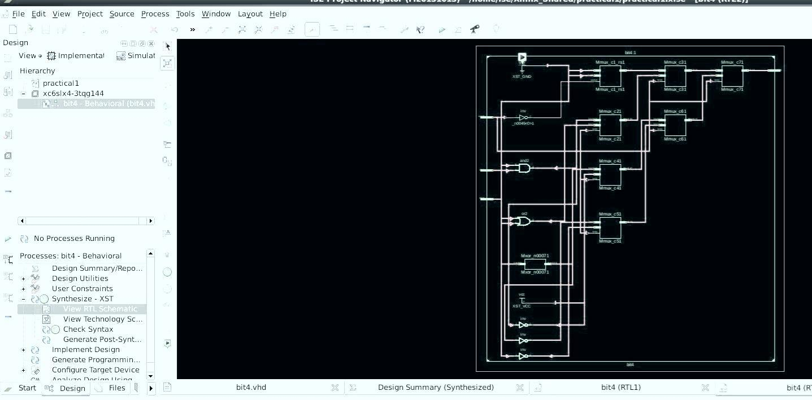

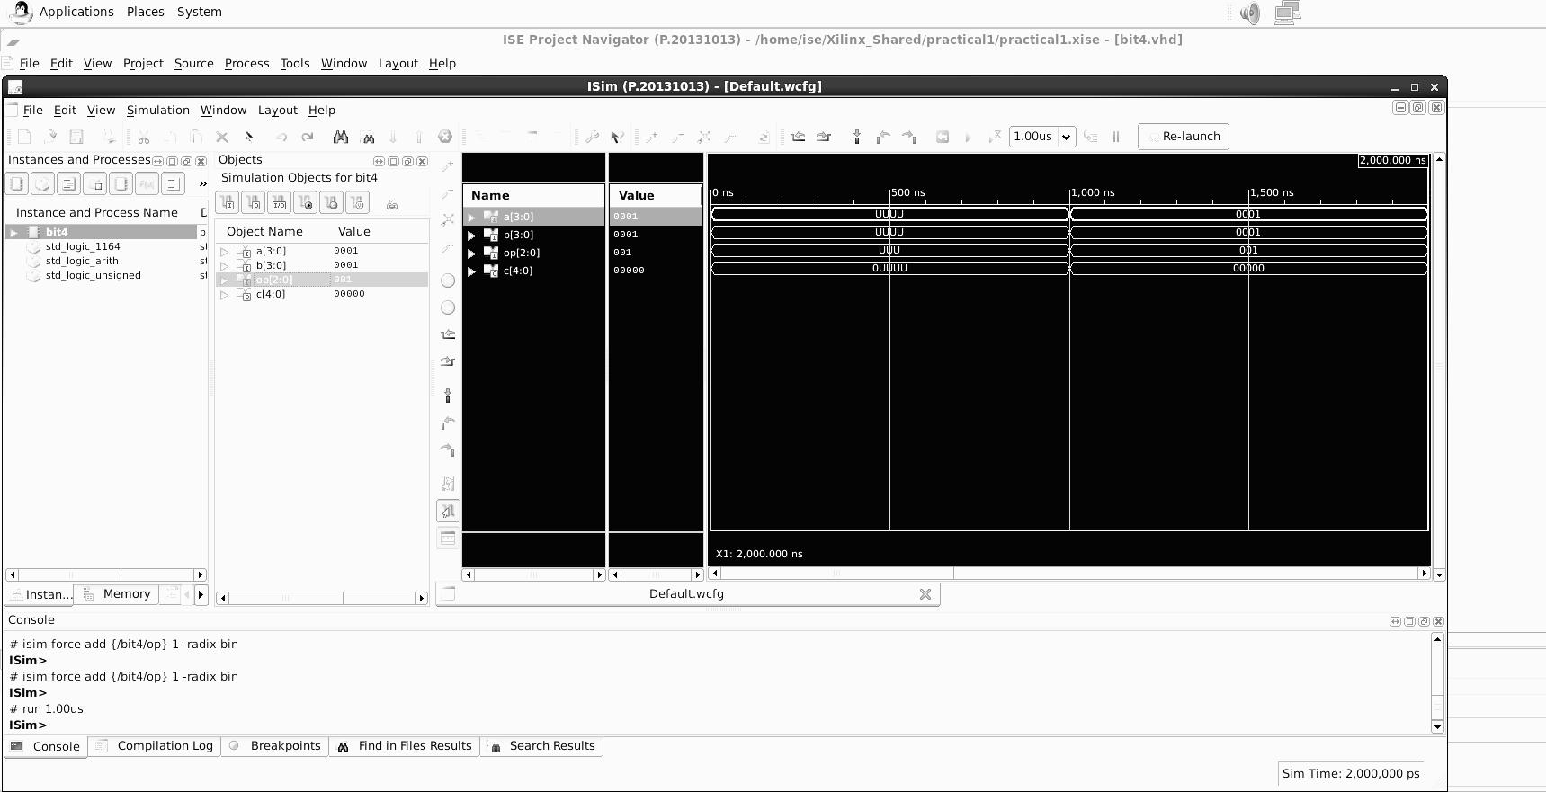

SHIFT REGISTER Program:-
library IEEE;
use IEEE.STD_LOGIC_1164.ALL;
entity prr is Port
(clr : in STD_LOGIC;
sel : in STD_LOGIC_VECTOR (1 downto 0);
shf_load : in STD_LOGIC;
serial_in : in STD_LOGIC;
clk : in STD_LOGIC;
d : in STD_LOGIC_VECTOR (3 downto 0);
q : inout STD_LOGIC_VECTOR (3 downto 0) );
end prr;
architecture Behavioral of prr is
begin
process(clk, clr)
begin -- Asynchronous active-low clear
if clr = '0' then
q <= "0000"; -- Positive clock edge
elsif rising_edge(clk) then -- Parallel Load
if shf_load = '0' then
q <= d;
else
case sel is -- Shift Right
when "00" => q <= serial_in & q(3 downto 1); -- Shift Left
when "01" => q <= q(2 downto 0) & serial_in; -- Rotate Left
when "10" => q <= q(2 downto 0) & q(3); -- Rotate Right
when "11" => q <= q(0) & q(3 downto 1);
when others => q <= q; end case; end if;
end if;
end process;
end Behavioral;

OUTPUT:-
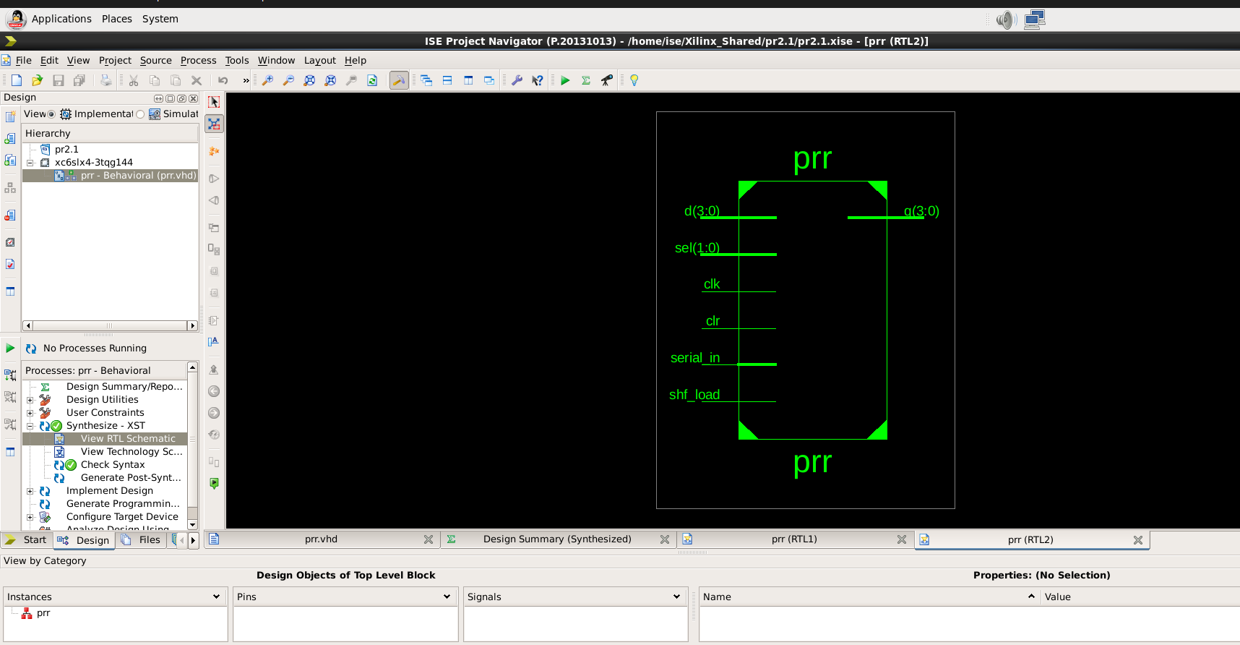

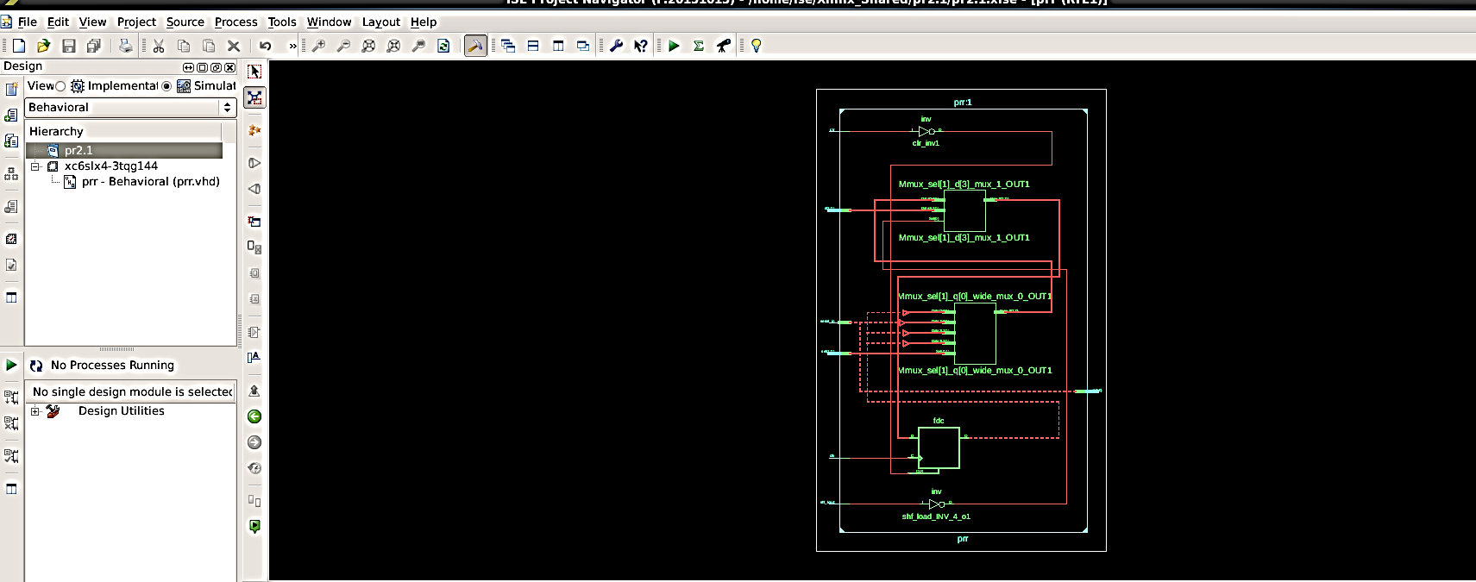

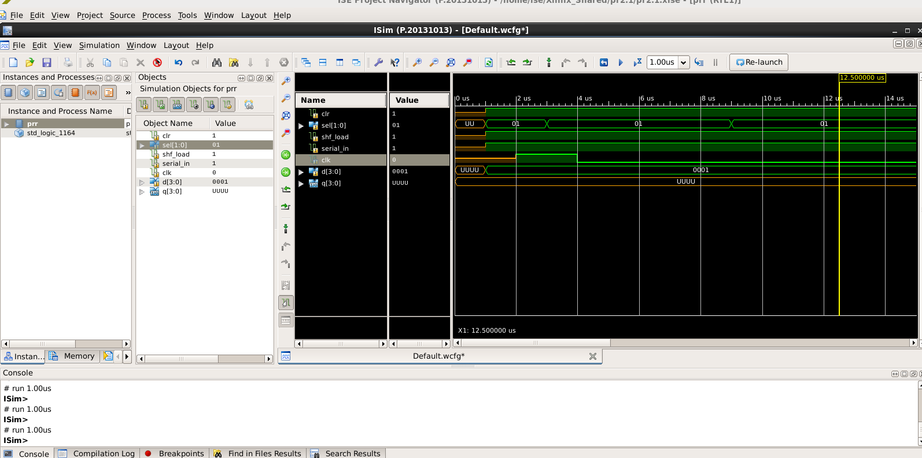
FIFO Program:-
library IEEE;
use IEEE.STD_LOGIC_1164.ALL;
use IEEE.NUMERIC_STD.ALL;
entity fifo is
port (
clk: in std logic;
rst: in std_logic;
enw : in std logic; write enable
enr : in std_logic; read enable
datain: in std_logic_vector(7 downto 0);
dataout out std_logic_vector(7 downto 0);
empty: out std_logic;
full:out std_logic
);
end fifo;
architecture Behavioral of fifo is
constant DEPTH: integer := 16;
type memory_type is array (0 to DEPTH-1) of std_logic_vector(7 downto 0);
signal memory: memory_type:= (others => (others => '0'));
signal readptr, writeptr: unsigned(3 downto 0) := (others => '0');
signal dataout_reg: std_logic_vector(7 downto 0);
signal full_reg, empty_reg: std_logic := '1';
begin
dataout <= dataout_reg;
full <= full_reg;
empty < empty_reg;
process(clk, rst)
begin
if rst = '1' then
readptr <= (others => '0');
writeptr <= (others => '0');
full_reg <= ‘0’:
empty_reg <= '1';
dataout_reg <= (others => '0');
elsif rising edge(clk) then
--Write operation
if (enw= '1' and full_reg = '0') then
memory(to_integer(writeptr)) <= datain;
writeptr< writeptr + 1;
end if;
--Read operation
if (enr= '1' and empty_reg = '0') then
dataout_reg <= memory(to_integer(readptr));
readptr< readptr + 1;
end if;
--Update flags
if (writeptr +1 readptr) then
full_reg <= '1';
else
full_reg <= '0';
end if;
if (readptr= writeptr) then
empty_reg <= '1';
else
empty_reg <= '0';
end if;
end if;
end process;
end Behavioral;

OUTPUT:- 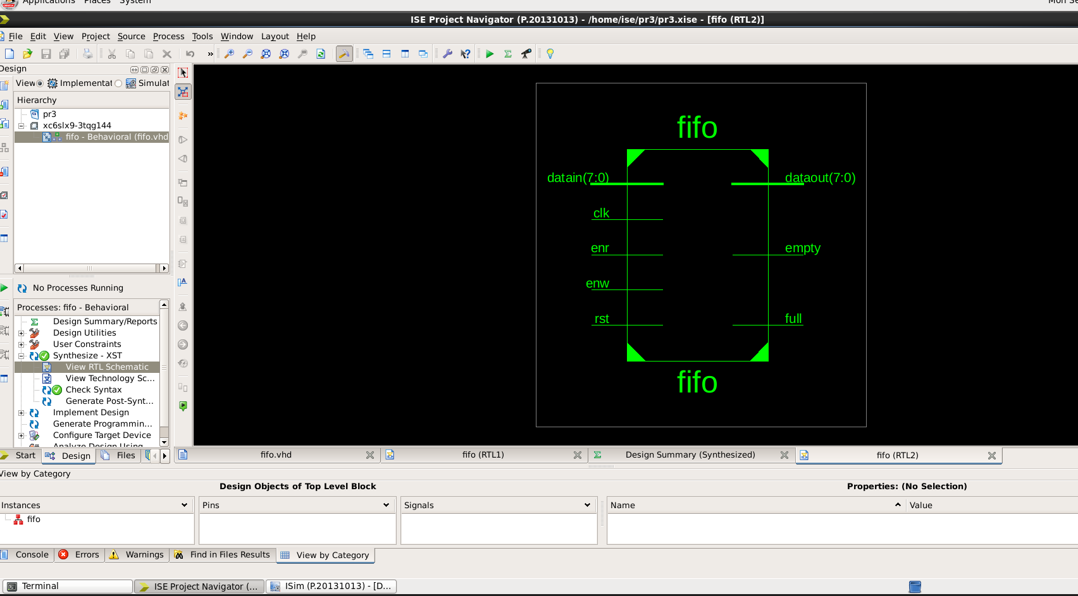

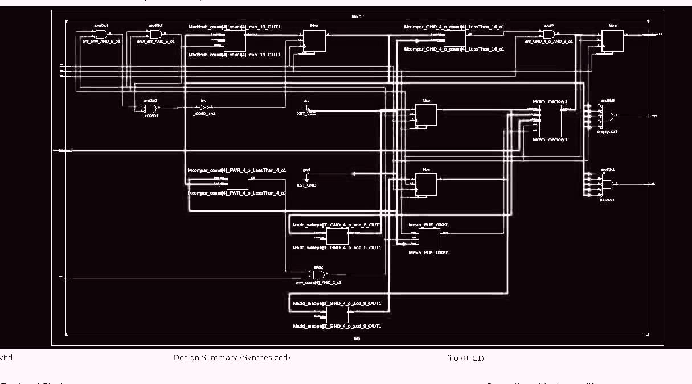

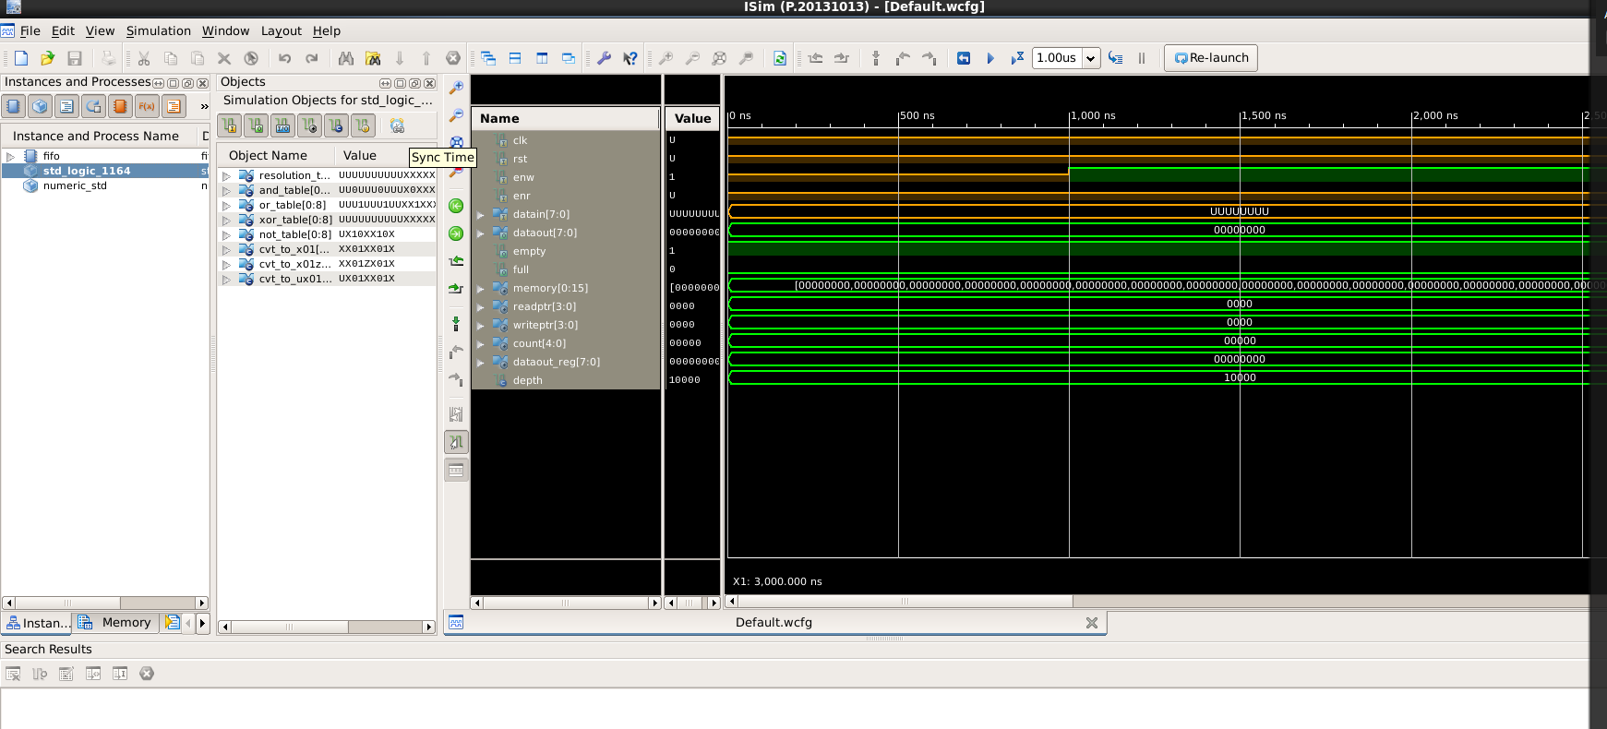

MOD N COUNTER Program:-
library IEEE;
use IEEE.STD_LOGIC_1164.ALL;
use IEEE.NUMERIC_STD.ALL;
entity counter is
Port (
clk : in STD_LOGIC;
reset : in STD_LOGIC;
count : out STD_LOGIC_VECTOR (3 downto 0)
);
end counter;
architecture Behavioral of counter is
signal count_t : STD_LOGIC_VECTOR (3 downto 0);
begin
process(clk, reset)
begin
if (reset = '1') then
count_t <= "0000";
elsif (clk'event and clk = '1') then
count_t <= std_logic_vector(unsigned(count_t) + 1);
end if;
end process;
count <= count_t;
end Behavioral;
OUTPUT:-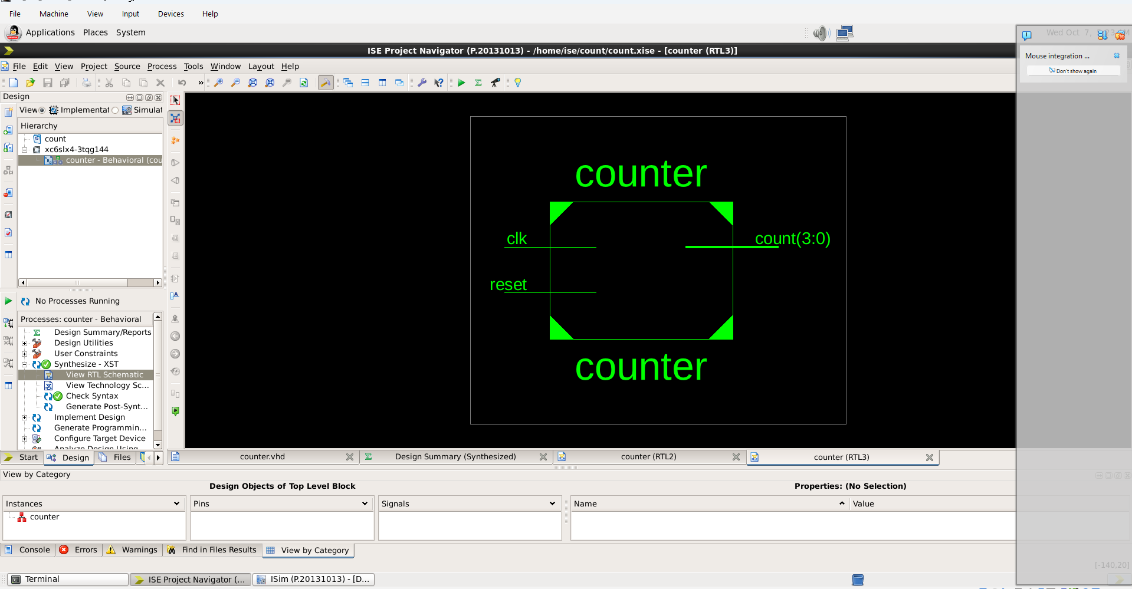

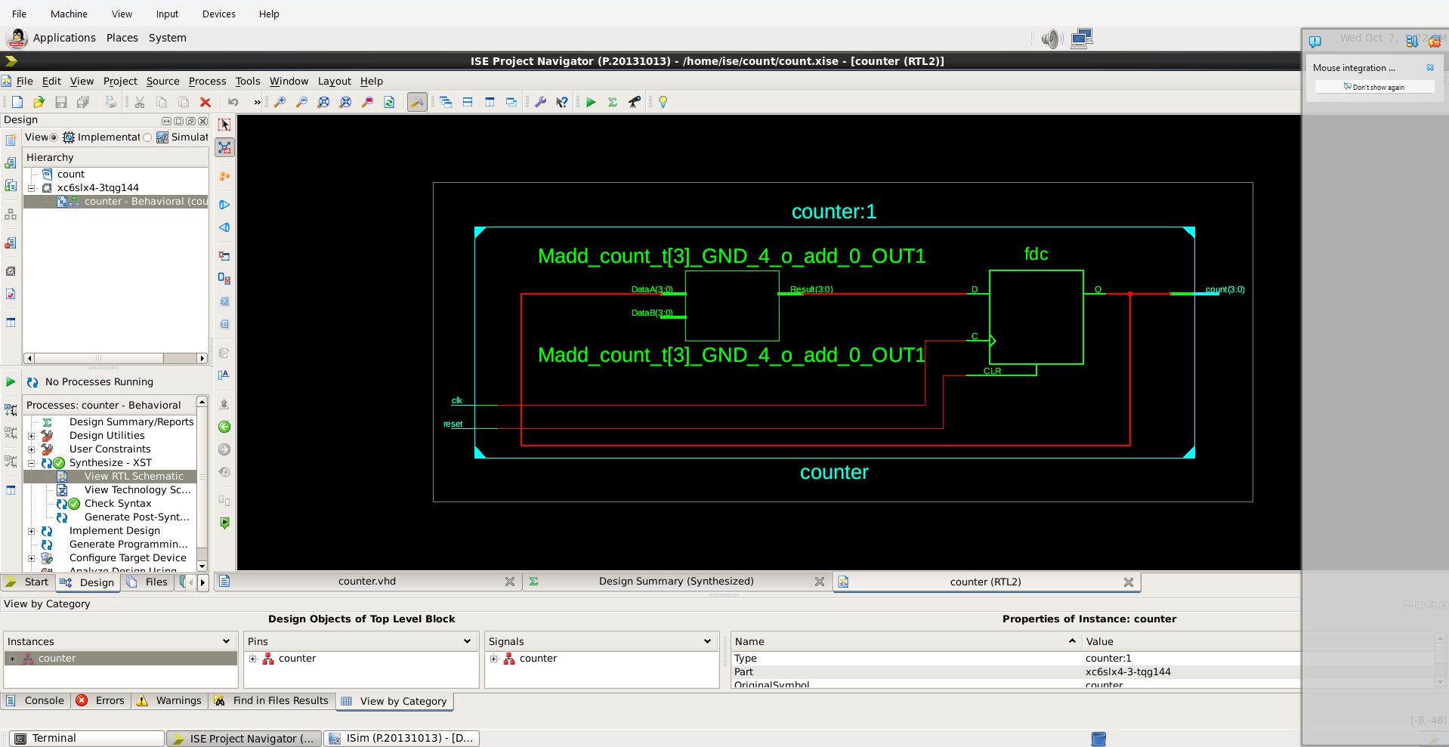

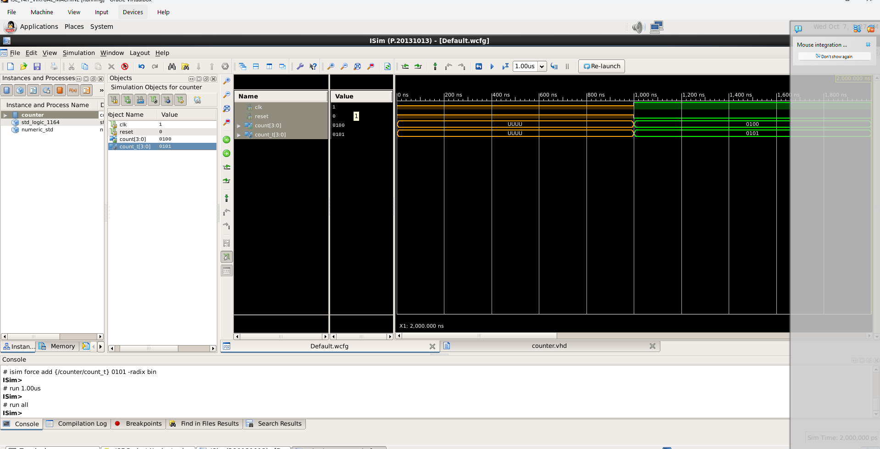

LCD Program:-
library IEEE;
use IEEE.STD_LOGIC_1164.ALL;
use IEEE.NUMERIC_STD.ALL;
entity LCD_interface is
Port (
clk : in STD_LOGIC_VECTOR(0 downto 0);
lcd_rw : out STD_LOGIC_VECTOR(0 downto 0);
lcd_e : out STD_LOGIC_VECTOR(0 downto 0);
lcd_rs : out STD_LOGIC_VECTOR(0 downto 0);
data : out STD_LOGIC_VECTOR(7 downto 0)
);
end LCD_interface;
architecture Behavioral of LCD_interface is
constant N : integer := 17;
type arr is array (1 to N) of
STD_LOGIC_VECTOR(7 downto 0);
constant data_s : arr := (
X"38", -- 8-bit mode, 2-line display
X"0C", -- Display ON, cursor OFF
X"06", -- Entry mode
X"01", -- Clear display
X"C0", -- Move cursor to second line
X"57", -- W
X"45", -- E
X"4C", -- L
X"43", -- C
X"4F", -- O
X"4D", -- M
X"45", -- E
X"20", -- Space
X"45", -- E
X"4E", -- N
X"54", -- T
X"43" -- C
);
begin
lcd_rw(0) <= '0';
process(clk(0))
variable i : integer range 0 to 2000000 := 0;
variable j : integer range 1 to N := 1;
begin
if rising_edge(clk(0)) then
if i < 2000000 then
i := i + 1;
else
i := 0;
if j <= 5 then
lcd_rs(0) <= '0';
else
lcd_rs(0) <= '1';
end if;
data <= data_s(j);
lcd_e(0) <= '1';
if j < N then
j := j + 1;
else
j := 5;
end if;
end if;
if i = 100000 then
lcd_e(0) <= '0';
end if;
end if;
end process;
end Behavioral;

OUTPUT:-



